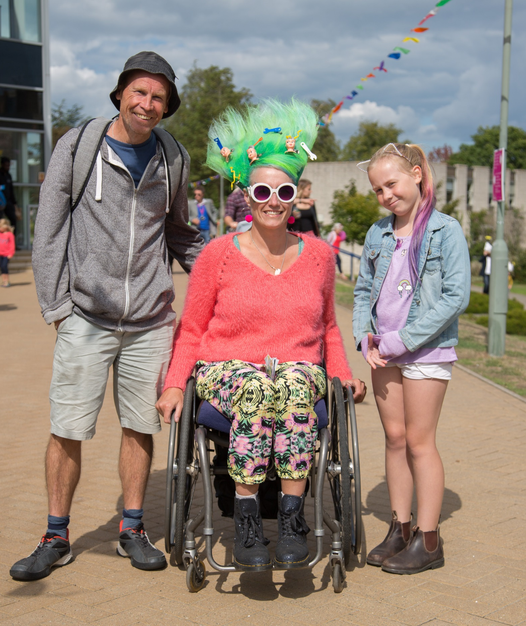
bOing! Family Festival Photo by Manu Palomeque
Gulbenkian is a leading 21st Century international arts centre working with a range of creative partners and offering an engaging, innovative and high quality arts programme.

To ensure the best use of our facilities please notify the Tickets & Information Office of your requirements when booking on 01227 769075 or by email: gulbaccess@kent.ac.uk.

More information, journey videos and an accessibility welcome video can be found on our Accessibility page on the Gulbenkian website: https://thegulbenkian.co.uk/accessibility/

Watch the Gulbenkian Accessible Welcome Video:
https://www.youtube.com/watch?v=GJk4NXMpe-k

Contents

Page 3 Access Scheme

Page 4 Mobility requirement information

Page 5 Visual/Hearing Impairment information

Page 6 Square Peg Arts

Page 7 Getting to Gulbenkian

Page 8 Site description

Access Scheme
Gulbenkian’s Access Scheme is a free scheme for people with physical, sensory or learning disabilities. As a member of our Access Scheme, you may be entitled to concessionary ticket prices for some events, or a free companion seat. All companion tickets are subject to availability and may not be available for certain performances.
By joining this scheme, you can keep up to date on offers and information about forthcoming events at Gulbenkian. Joining the scheme will allow you to book Registered Disabled/ Access Scheme concession tickets online, by phone and in person. When booking tickets in person or on the phone, please mention if you require an aisle seat, a seat near the front, a wheelchair space, require a companion, or have any other requirements. In purchasing an Access Scheme concession rate ticket, you agree that the ticket(s) will only be used by a disabled person, and his/her companion, as defined by the Equality Act 2010.
Not a member of the scheme yet? We'll reserve your tickets
If you would like to book tickets at the Registered Disabled/ Access Scheme concession rate or require a companion ticket but haven't signed up to the Access Scheme yet, please visit our website to download the application form (https://thegulbenkian.co.uk/accessibility/) or contact boxoffice@kent.ac.uk who will be able to supply an application form, reserve your tickets and process your application. Once the application form has been received, we aim to process the form within 7 working days.

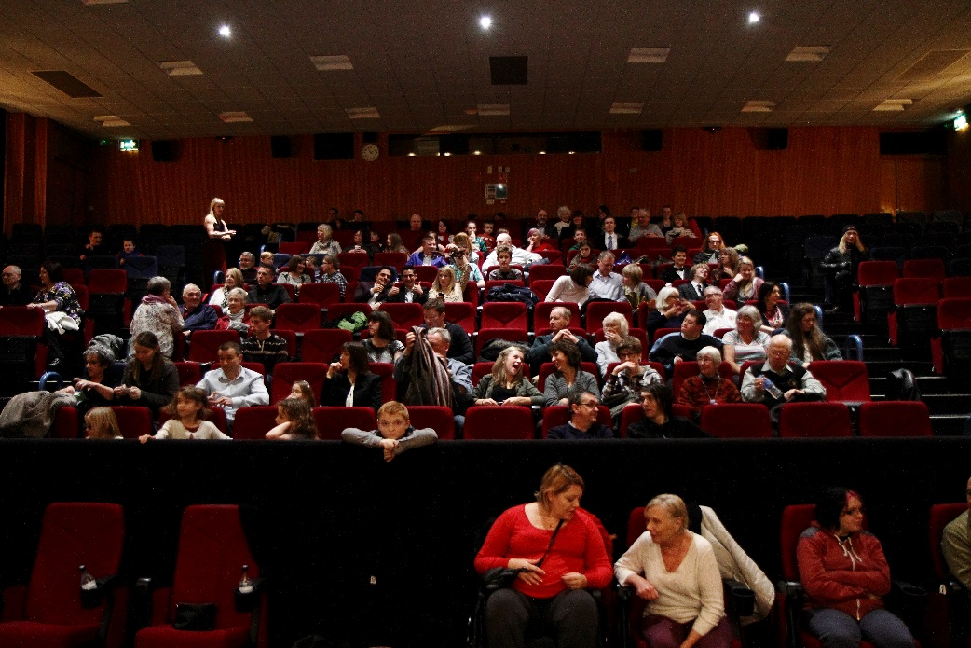

Mobility Requirements
For ticketed events, if you require a wheelchair space please let us know when booking.
If you require an earlier entry into the venue please go to the ticket and information desk where a Duty Manager will assist you.
If you are concerned about seating arrangements for pop up and outdoor locations, we suggest arriving 20 to 30 minutes earlier to secure a good viewing point.
Disabled parking spaces are available in the Central car park adjacent to Gulbenkian and Rutherford car park.
Level access across the site, including to all venues.

Toilet & Changing Facilities
Disabled accessible toilet facilities are located in Gulbenkian, Colyer-Fergusson, Jarman and Grimond.
Accessible hoist toilet facilities are available in Templeman Library.
A changing places hygiene room is located in Templeman Library. Please note that to gain access there is a phone located on the wall in the foyer of the library.
Baby changing facilities are available at each venue.



Visual / Hearing Impairments
Infra-Red Audio system for the hearing impaired available in Gulbenkian.
We also provide AD and Caption kits - Dolby Accessibility Solution - Dolby Professional

Assistance dogs welcome.

Pre-show visits/Touch tours: We offer pre-show visits and touch tours on some events. Please contact our Front of House manager Helen on boxoffice@kent.ac.uk or phone ticket office on 01227 769075.
Relaxed events: We offer relaxed performances/screenings.
Monthly Accessible Film Club, run in partnership with Square Peg Arts
Please see our season programme or website for more information about relaxed events.
Relaxed Performances/screenings are specifically designed to welcome people who will benefit from a more relaxed performance environment, including guests on the Autistic Spectrum, sensory and communication disorders, or a learning disability or parents who want to attend our performances with young children. There is a relaxed attitude to noise and movement in the auditorium and we make some small changes to the light and sound effects.
Look out for these logos in our season guides:
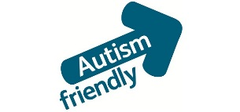

Square Peg Arts
Square Pegs Arts is an award-winning charity who run activities and projects for young people and adults who have learning disabilities, autism or social communication difficulties.
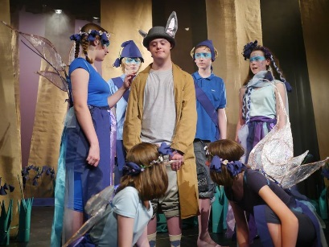
Square Pegs Drama Club
Weekly, Saturdays, 1-2.30pm
Our Canterbury drama group is for anyone aged 16 to 25 who’s interested in drama but who also finds it a bit difficult fitting in.
Running weekly during term times, the group is run by professional specialist artists and supported by trained volunteers. We have lots of experience in working with young people of all abilities to create theatrical productions, develop communication and social skills, increase confidence and self-esteem.
Square Pegs Singers!
Monthly Saturdays, 10am-12.30pm
Singing workshops for anyone over the age of 14 years and for all abilities. The sessions are run by a professional vocal coach and supported by trained volunteers. Each workshop participants learn and perform a whole new song (with harmonies!)
For more information on either of these groups, go to www.squarepegsdramaclub.com or email assistant@squarepegsdramaclub.com

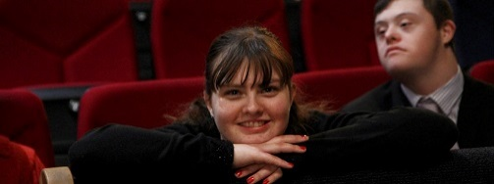
Accessible Film Screenings!
Gulbenkian, in association with Square Pegs, run a monthly film screening that is open to all, especially those with autism and learning disabilities. Films are screened in a relaxed, comfortable, safe, inclusive environment. Visit www.thegulbenkian.co.uk or contact Tickets & Information on 01227 769075 or email boxoffice@kent.ac.uk to find out what screenings are coming soon.

Getting to Gulbenkian
By Bus
The Gulbenkian bus stop is only 5 mins walk to the venue. Plan your journey at: stagecoachbus.com/eastkent
By Car
Follow traffic direction signs. For sat navs use postcode CT2 7NB.
Free parking is available to Gulbenkian customers after 5pm on weekdays and all day at weekends in any University car park.
For Gulbenkian customers attending events between Monday and Friday 8am to 5pm please park in the Visitor Pay and Display car parks on Campus. £2 for 3 hours and £6 all day (8am-5pm). The nearest Visitor Pay and Display is the Central Car Park (formerly known as Gulbenkian Car Park).
Accessible bay parking
Available in Central Visitor Car Park, adjacent to Gulbenkian and Rutherford Car Park (approx. 5-10mins away from Gulbenkian).
More information, including a Map of University of Kent Car Parks can be found online: https://thegulbenkian.co.uk/your-visit/parking/ or email: gulbaccess@kent.ac.uk

Journey videos:
Follow the journey from the Central Car Park to Gulbenkian in real time: https://www.youtube.com/watch?v=J9il-Z3jLqE
Follow the journey from Giles Lane Car Park to Gulbenkian:
https://www.youtube.com/watch?=2&v=6HVLtc5bw8o
Follow the journey from Giles Lane Bus Stop to Gulbenkian: https://www.youtube.com/watch?v=wcqeYBimntk
Follow the journey from Keynes College Bus Stop to Gulbenkian:
https://www.youtube.com/watch?v=FznH1IkLKNU

Site Description
Gulbenkian hosts a variety of indoor and outdoor events in the University of Kent grounds and venues. The majority of the area is flat and are there is a network of paths. However there can be mobility problems on grass areas, particularly in bad weather conditions. If it rains it may get muddy and access around the site (other than on paths) may be very difficult. Electric wheelchairs can get to most areas without too much trouble but the ground can be uneven in places.
There are around 15 different venues and performance areas, which are located around the site. Mainly events take place in Gulbenkian, which has a theatre, cinema, music hall and cafe.

Watch the Gulbenkian Accessible Welcome Video:
https://www.youtube.com/watch?v=GJk4NXMpe-k
Gulbenkian (exterior of building):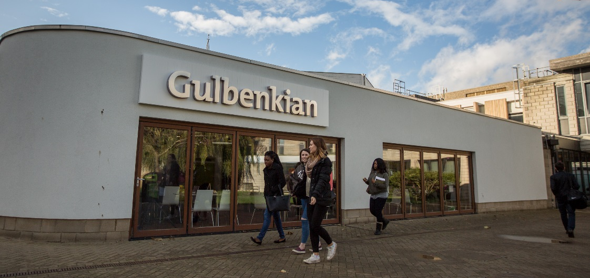
Café:
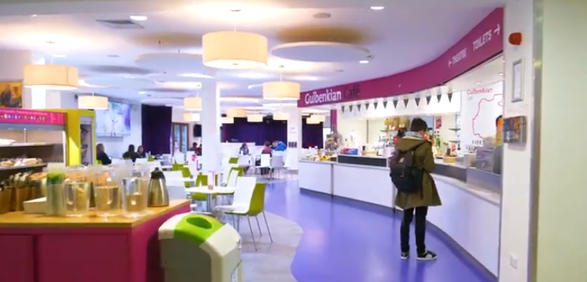
Tickets & Information Desk:
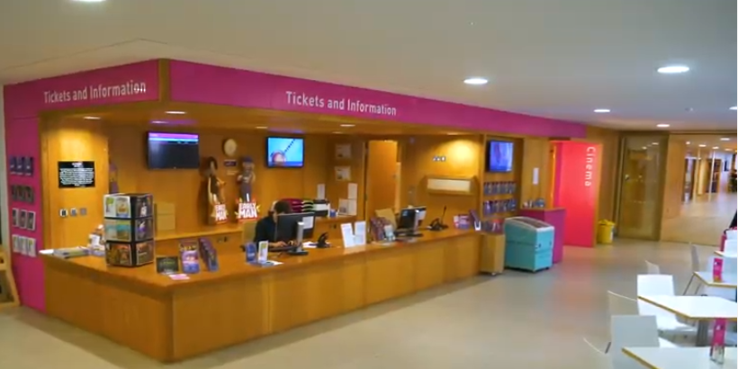
Theatre auditorium:
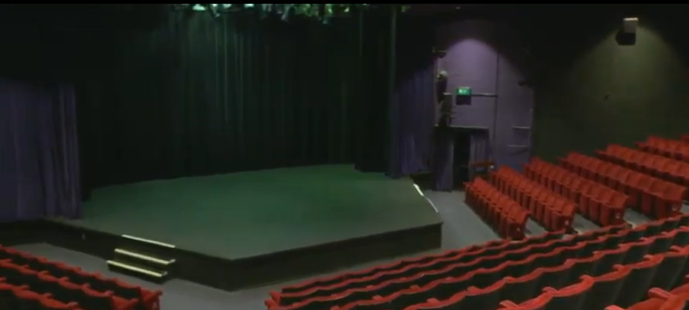
Cinema auditorium:
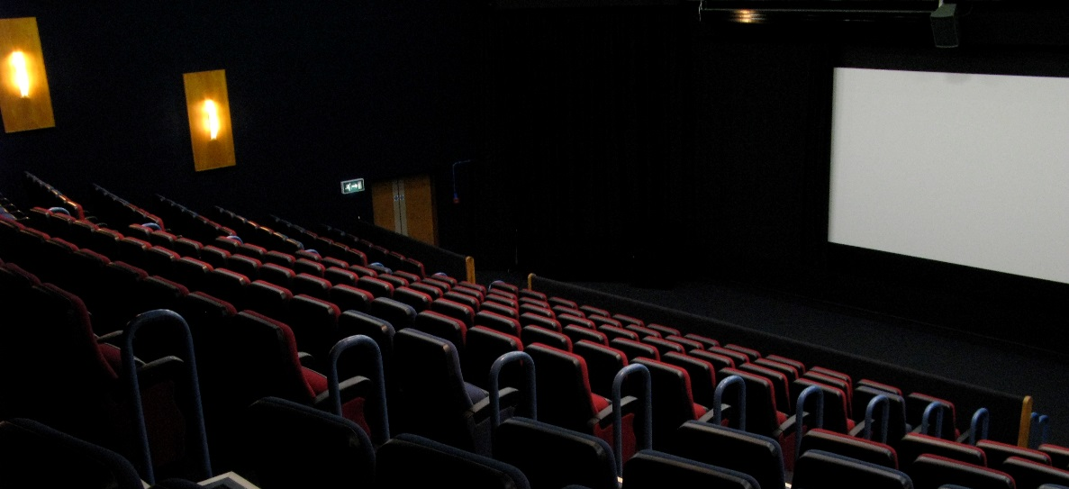

Colyer-Fergusson Hall:
