Access Membership Registration

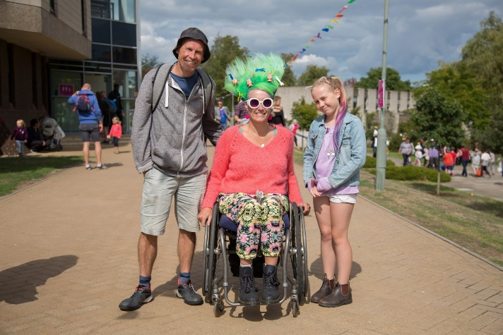
Gulbenkian’s Access Scheme is a free scheme for people with physical, sensory or learning disabilities. As a member of our Access Scheme, you may be entitled to concessionary ticket prices for some events, or a free companion seat. All companion tickets are subject to availability and may not be available for certain performances.

By joining the Access Scheme, you can keep up to date on offers and information about forthcoming events at Gulbenkian. Joining the scheme will allow you to book Disabled/ Access Scheme concession tickets online, by phone and in person. When booking tickets in person or on the phone, please mention if you require an aisle seat, a seat near the front, a wheelchair space, require a companion, or have any other requirements. In purchasing an Access Scheme concession rate ticket, you agree that the ticket(s) will only be used by a disabled person, and his/her companion, as defined by the Equality Act 2010.

However, if you wish to book tickets immediately, please contact Tickets and Information on: 01227 769075

Gulbenkian Access Scheme Registration
If you would like assistance filling out this form or would like it in a different format, please contact Tickets & Information who will be pleased to assist you: Email boxoffice@kent.ac.uk or telephone: 01227 769075
By completing this form, you will be giving consent for Gulbenkian to process your Personal Information and Special Person Data for Access Membership. Full details of how we use your data can be found here thegulbenkian.co.uk/privacy-policy

Title:

First Name:

Surname:

Address:

Postcode:

Telephone:

Email:

Access and Seating Requirements
☐Wheelchair Space

☐Accessible seat for wheelchair transfer
☐Assistance dog
☐Flat Access
☐Strobe Sensitivity
☐Epilepsy

Auxiliary Aids and Services
☐Captioning
☐Audio Description
☐Hearing Loop
☐BSL
☐Large print brochures
Any additional Information:

Access Booker
If you require another person to help with bookings on your behalf, please give their contact details here:
Name:

Phone:

Address:

Email:

Companion tickets
If you require continual supervision or assistance inside the auditorium during performances, you may be eligible for a free companion ticket. Please see Companion Ticket Form
Please tick this box to apply for free companion tickets☐

Companion Ticket Form
The Free Companion ticket offer is available to Access Scheme Members who require assistance or supervision throughout the performance.
Should you wish to apply, please ask a relevant professional to complete, sign and date the following questionnaire, accompanied by an official stamp or headed letter.
Wheelchair users are automatically eligible for a free companion ticket should they require one.

I, (name of Relevant Professional) hereby confirm that (name of individual)
requires the following assistance when attending Gulbenkian
☐Assistance, travelling to and from the Gulbenkian, or during intervals only
☐Assistance or supervision throughout the performance

I can confirm that I have made this appraisal in a professional capacity.

Signed Date Official Stamp

