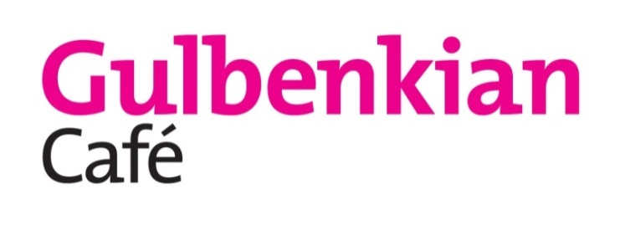

**Breakfast**

Monday – Friday 8.00 – 10.30

Gluten Free Bread is available on all breakfast dishes

**Toast with Jam (V) £2.00**

Choice of white or brown sliced Wilmshurst bakery bread served with jams

**Breakfast Baguette £3.50**

Choice of a Bacon, Sausage or Vegetarian Sausage in a freshly baked white baguette

Add Egg 80p

**Sweet Potato Hash £3.00 (Ve) (GF)**

Pan fried diced potato, sweet potato, red onion and dill

Add Poached Egg 80p

**Preston Butchers’ St George Sausage Potato Hash £4.00 (GF)**

Slices of St George sausage pan fried with diced potato, sweet potato, red onion and dill topped with a poached egg



**Build your own breakfast**

1. **Choose your base £2.00**

**White Toast**

**Brown Toast**

**Sourdough Toast**

**Gluten Free Toast**

1. **Choose your toppings**

**Poached Egg, Bacon, Baked Beans**

**80p each**

**Vegetarian Sausage, St George Sausage**

**£1.00 each**

**Smashed Avocado and Chilli**

**£2.50 each**

**Mains**

**Chicken and Avocado Burger £8.50**

*Pan Seared chicken breast in sourdough bun with baby gem lettuce, avocado and chilli served with rustic chips and side salad*

***Swap your bun for salad!***

***Gluten free rolls available***

**Smoked Cheese and Bacon Burger £8.95**

*Preston Butchers steak burger topped with bacon and smoked cheese in a sourdough bun with rustic chips*

**Lemon and Honey Mustard Chicken Thighs £8.00 (GF)**

*Served on a medley of vegetables and roasted new potatoes*

**Breaded Fish Finger Sandwich £8.50**

*Homemade breaded Plaice goujons in ciabatta served with chips*

**Chicken and Avocado Caesar Salad £7.00**

*Grilled Preston butchers chicken pieces, avocado slices, eggs, crispy bacon and croutons*

***Gluten free with no croutons***

**Smoked Haddock and Salmon Fishcakes £7.50**

*Applewood smoked cheddar filled fishcakes served on a bed of carrots, broccoli and roasted new potatoes drizzled with a lemon and herb dressing*

**Kentish Mac and Cheese £6.50 (V)**

*Topped with tortilla chips*

***Add Smoked Bacon £1.00***

**Gluten free penne pasta available**

**Cauliflower and Quinoa “Meatballs” and Spaghetti £7.50 (Ve)**

*Homemade cauliflower and quinoa “meatballs” served in a tomato sauce and spaghetti*

**Gluten free penne pasta available**

**10” Pesto, Red Onion and Tomato Pizza (V)**

**Mozzarella Cheese £7.50**

**Vegan Cheese £7.80 (Ve)**

**Add Chicken £1.50**

*Freshly rolled dough topped with nut free pesto, sliced tomatoes, red onion and topped with mozzarella cheese*

***Gluten free option available***

**Greek Salad £6.95 (V)**

*Creamy feta cheese on a bed of diced peppers, tomatoes, spring onion, cucumber with rosemary croutons*

***Gluten free with no croutons***

**Anto’s Lentil Naanwich £7.00 (V)**

*Fried Lentil vada* ***(lentils, onion, coriander, ginger)*** *in a naan pocket with raita served with Indian style salad*

***Make it vegan by swapping your naan for a paratha bread* (Ve)**



**Jacket Potatoes**

Monday – Sunday 12.00 – 17.00

**Cheese and Baked Beans (GF) (V) £4.60**

**Vegan Cheese available**

**Tuna Mayonnaise (GF) £4.60**

Add cheese 60p

All jacket potatoes served with butter and side garnish

**Side Dishes**

**Bowl of Rustic Chips (V) (GF) £2.50**

**Add Cheese £0.60**