Gulbenkian’s Access Scheme is a free scheme for people with physical, sensory or learning disabilities. As a member of our Access Scheme, you may be entitled to concessionary ticket prices for some events, or a free companion seat. All companion tickets are subject to availability and may not be available for certain performances.
By joining this scheme, you can keep up to date on offers and information about forthcoming events at Gulbenkian. Joining the scheme will allow you to book Registered Disabled/ Access Scheme concession tickets online, by phone and in person. When booking tickets in person or on the phone, please mention if you require an aisle seat, a seat near the front, a wheelchair space, require a companion, or have any other requirements. In purchasing an Access Scheme concession rate ticket, you agree that the ticket(s) will only be used by a disabled person, and his/her companion, as defined by the Equality Act 2010.
Not a member of the scheme yet? We'll reserve your tickets
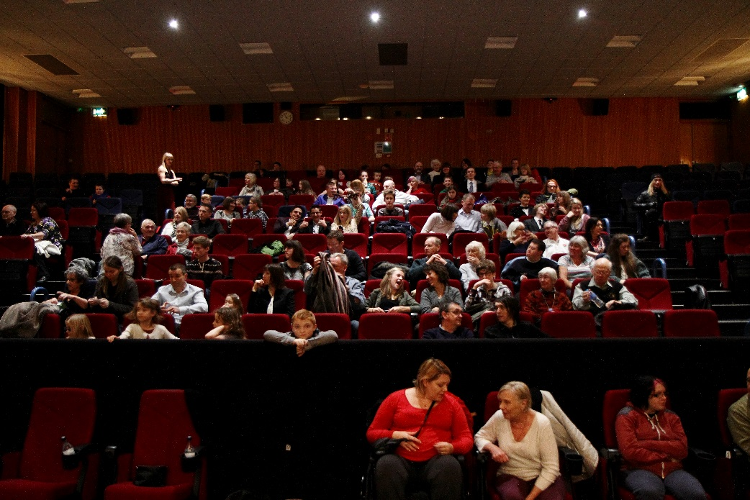
If you would like to book tickets at the Registered Disabled/ Access Scheme concession rate or require a companion ticket but haven't signed up to the Access Scheme yet, please contact boxoffice@kent.ac.uk who will be able to supply an application form, reserve your tickets and process your application. Once the application form has been received, we aim to process the form within 7 working days.

Gulbenkian Access Scheme Registration
If you would like assistance filling out this form or would like it in a different format, please contact Tickets and Information who will be pleased to assist you: Email boxoffice@kent.ac.uk or telephone: 01227 769075
By completing this form, you will be giving consent for Gulbenkian to process your Personal Information and Special Person Data for Access Membership. Full details of how we use your data can be found here thegulbenkian.co.uk/privacy-policy
Title: First Name: Surname:
Address:

Postcode:
Telephone: Mobile:
Email:
How would you prefer to be contacted?
Telephone Email Post
What are your access requirements? :
Aisle Seat Captioning

Wheelchair space Room for assistance dog

Audio-description Seat for a companion

Level access seating Hearing Loop

Other (please specify):

If you require a free companion seat, we request that you bring one of the following documents on your first visit to Gulbenkian. After we have seen one of these documents, you won’t need to bring them in again.
- Disability Living Allowance (DLA)
- Attendance Allowance (AA)
- Personal Independence Payment (PIP)
- Armed Forces Independence Payment (AFIP)
- Severely Sight Impaired Registration (formerly Registered Blind)
- Sight Impaired Registration (formerly Partially Sighted)
May we contact you? If you would like to receive information about future events and other developments from Gulbenkian, please select one or more choices below.
Post Email
Season Guide Preference:
Standard Print
Large Print
Other -please specify: _______________________________

To join, please return this completed form to:
FAO Tickets and Information, Gulbenkian, University of Kent, Canterbury, Kent, CT2 7NB
Or email to boxoffice@kent.ac.uk

